# **REPORT OF MEDICAL STORE**

# **MANAGEMENT SYSTEM**

Introduction of the Project - Medical Store Management System:

The "Medical Shop Management System" has been developed to override the problems

prevailing in the practicing manual system. This software is supported to eliminate and

in some cases reduce the hardships faced by this existing system. Moreover this

system is designed for the particular need of the company to carry out operations in a

smooth and effective manner.

The application is reduced as much as possible to avoid errors while entering the data.

It also provides error message while entering invalid data. No formal knowledge is

needed for the user to use this system. Thus by this all it proves it is user-friendly.

Medical Shop Management System , as described above, can lead to error free, secure,

reliable and fast management system. It can assist the user to concentrate on their

other activities rather to concentrate on the record keeping. Thus it will help organization

in better utilization of resources.

Objective of Project on Medical Shop Management System:

The main objective of the Project on Medical Shop Management System is to

manage the details of Medical Shop, Medicine, Stocks, Sales, Expenses. It manages all

the information about Medical Shop, Users, Expenses, Medical Shop. The project is

totally built at administrative and and thus only the administrator is guaranteed the

access. The purpose of the project is to build an application program to reduce the

manual work for managing the Medical Shop, Medicine, Users, Stocks. It tracks all the

details about the Stocks, Sales, Expenses.

Functionalities provided by Medical Shop Management System are as follows:

* Provides the searching facilities based on various factors. Such as Medical Shop,

Stocks, Sales, Expenses.

* Medical Shop Management System also manage the Users details online for Sales

details, Expenses details, Medical Shop.

* It tracks all the information of Medicine, Users, Sales etc.
* Manage the information of Medicine.
* Shows the information and description of the Medical Shop, Stocks.
* To increase efficiency of managing the Medical Shop, Medicine.
* It deals with monitoring the information and transactions of Sales.
* Manage the information of Medical Shop.
* Editing, adding and updating of Records is improved which results in proper

resource management of Medical Shop data.

* Manage the information of Sales.
* Integration of all records of Expenses.

Features of the project Medical Shop Management System:

* Product and Component based
* Creating & Changing Issues at ease
* Reporting & Charting in more comprehensive way
* User Accounts to control the access and maintain security
* Simple Status & Resolutions
* Multi-level Priorities & Severities.
* Attachments & Additional Comments for more information.
* Accuracy in work.
* Easy & fast retrieval of information.
* Well designed reports.
* Decrease the load of the person involve in existing manual system.
* Access of any information individually.
* Work becomes very speedy.
* Easy to update information

About Medical Store Management System Project:

File handling has been extensively and effectively used for almost major functions. The whole project is based on file handling as all medical records are stored in file.

Data structure have been used to store and organize records. Overall, understanding this project will provide you valuable information on how to store, edit, search and delete data using file.

Here, we can input many information like medicine Id, rack no., cabinet no., supplier’s name, unit cost, [sales](https://www.codewithc.com/sales-management-system-project-c/) price, etc while adding a medicine into the store. We can also view information about report and billing.

Snapshots:

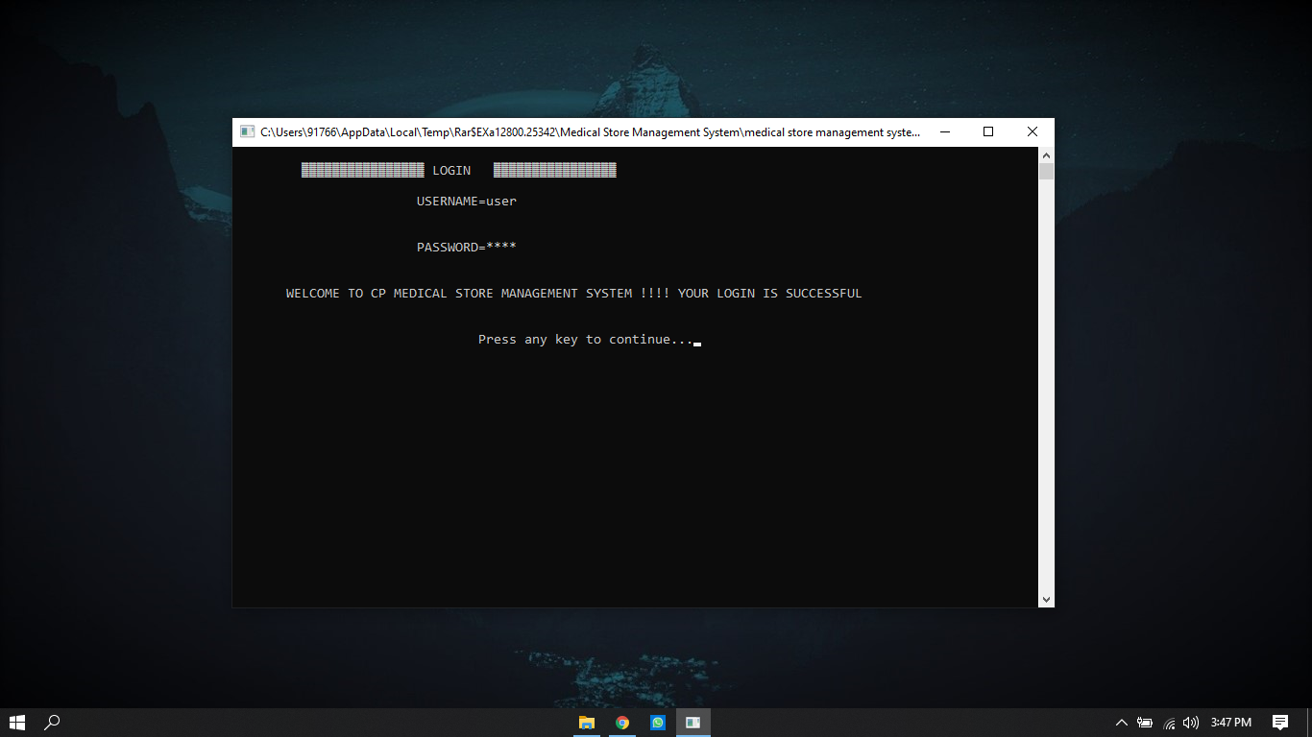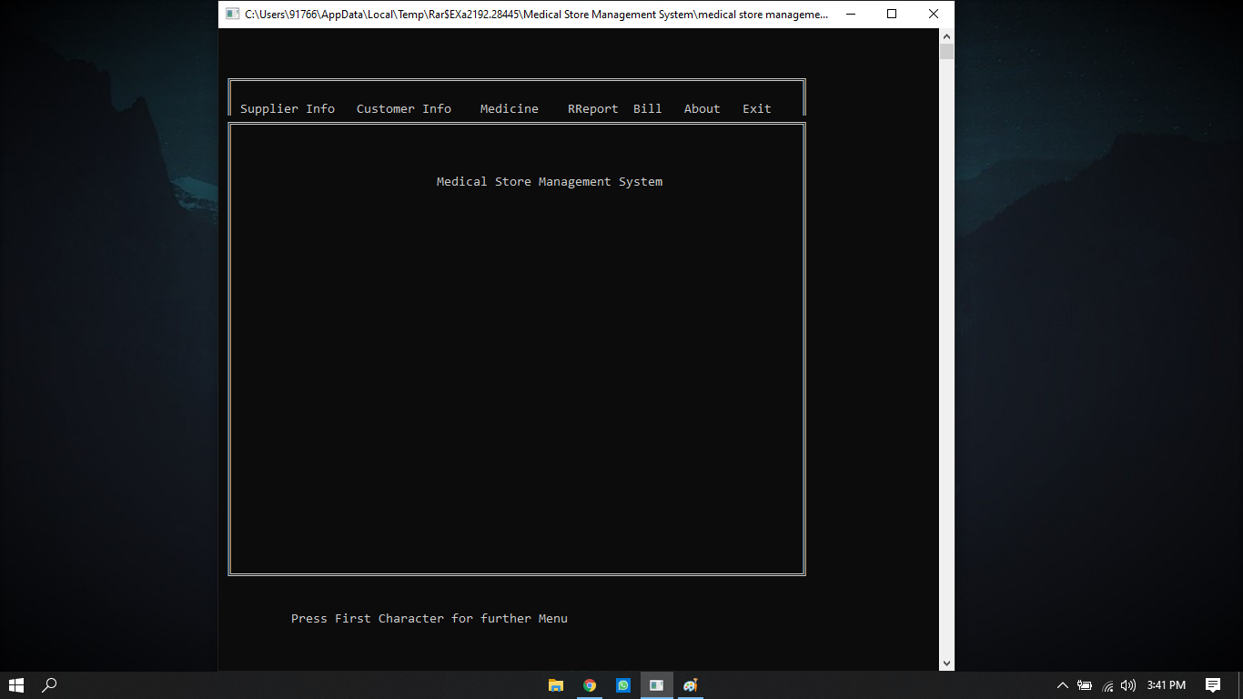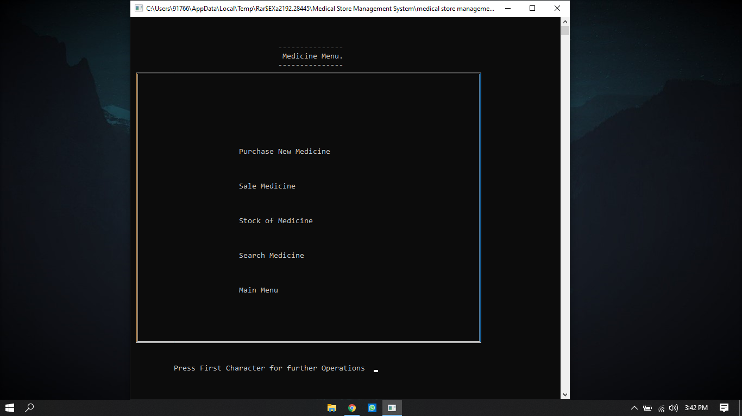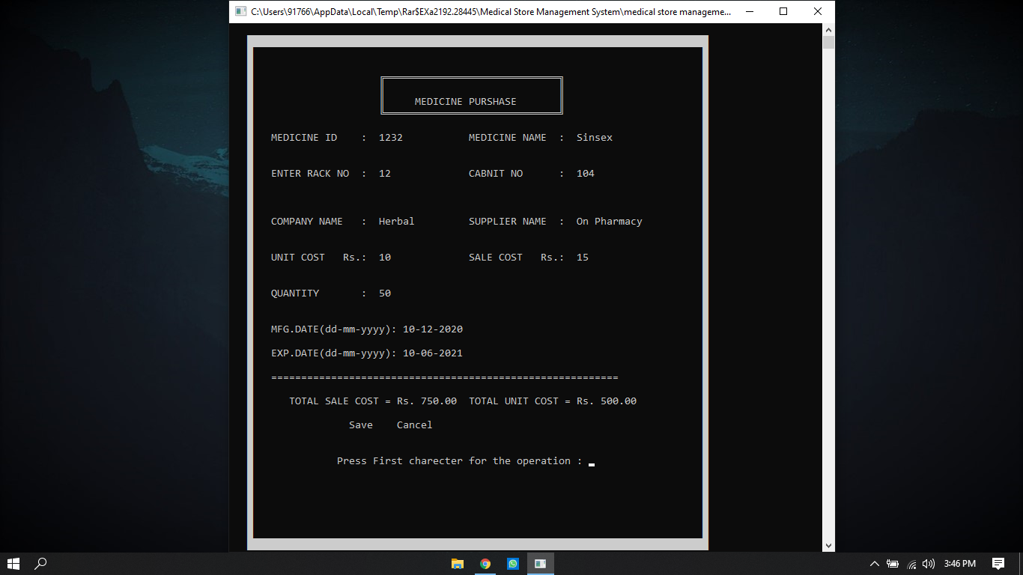

Limitation of Project on Medical Shop Management System:

Although I have put my best efforts to make the software flexible, easy to operate but limitations cannot be ruled out even by me. Though the software presents a broad

range of options to its users some intricate options could not be covered into it; partly

because of logistic and partly due to lack of sophistication. Paucity of time was also

major constraint, thus it was not possible to make the software foolproof and dynamic.

Lack of time also compelled me to ignore some part such as storing old result of the

candidate etc.

Conclusion:

This project is only a humble venture to satisfy the needs to manage project

work.The objective of this project is to provide a frame work that enables the manger to make reasonable estimates made within a limited time frame at the beginning of the

project and should be updated regularly as the project progresses.

References and Bibliography:

<https://www.geeksforgeeks.org/>

<https://codeforwin.org/>

<https://www.youtube.com/>